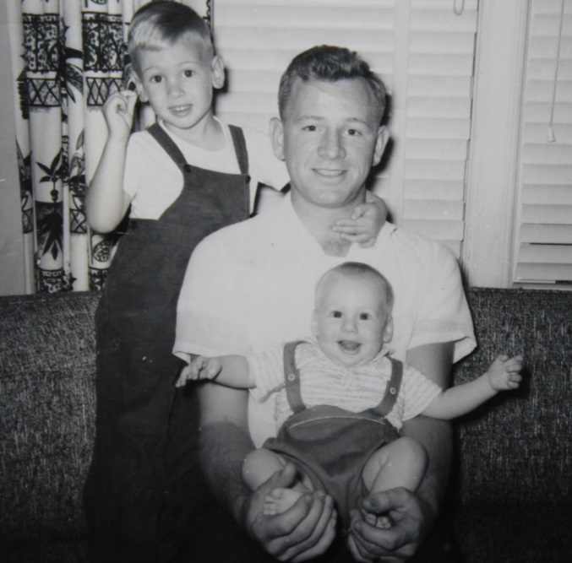

Daniel, Richard holding Gregory Harrington – 1958

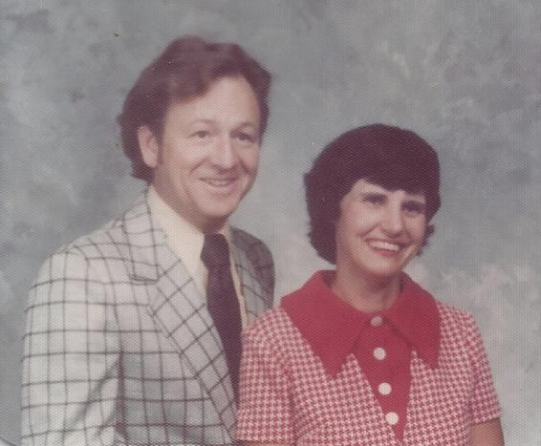

Dick & Lois Harrington – 1975